M4ACE ASSIGNMENT
Part 1: Hugging Face (The App Store of AI)
DELIVERABLE:

Part 2: Kaggle
DELIVERABLE:
https://www.kaggle.com/datasets/svaningelgem/crypto-currencies-daily-prices
I chose a data set in crypto currencies because it can be used to create AI engines that can predict market changes and give advice on profitable times to trade.

Part 3: Google Colab (Your First AI Workspace)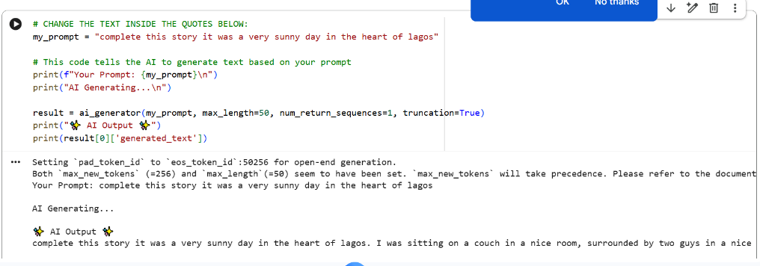
Part 4: GitHub (Your Digital Portfolio)
https://github.com/davidomolekun/ML-AI-M4ACE-OMOLEKUN-OSIGURU-DAVID

